**Project Report**

**Title of the Project- Zoo Explorer App**

**Course Code : CSE225**

**Course Title: Developing Android Apps**

**Submitted By:**

**Name: Prakhyat Singh**

**Reg No. 12218463**

**Submitted To:**

**Dr. Anuj Sharma**



**LOVELY PROFESSIONAL UNIVERSITY**

**DECLARATION**

I, am **Prakhyat Singh** , a student of Bachelor of Technology under CSE discipline at Lovely Professional University, Punjab, hereby declare that all the information furnished in this project report is based on my own work and is genuine

**Table of Contents**

# **Project Description:**

Zoo Explorer is a mobile application designed to enhance the experience of zoo visitors by providing an interactive, educational, and user-friendly digital companion. The app acts as a smart guide, offering real-time information about animals, navigational assistance across the zoo map, event schedules, and personalized recommendations based on user interests.

Built using **Kotlin** and **XML** for Android development, Zoo Explorer ensures smooth navigation between different sections of the app, with clean UI designs and optimized performance. The app uses **ViewBinding** for safe and easy access to UI components.

# **Key Features:**

* **Interactive Zoo Map:** Navigate the zoo with a detailed, interactive map that highlights animal locations, amenities, and event areas.
* **Animal Information:** Browse a rich library of animal profiles, each with images, species details, habitats, diets, and fun facts.
* **Event Schedule:** View daily schedules of special events, feeding times, and shows, with real-time notifications.
* **Favorites:** Save favorite animals or spots for quick access later.
* **Personalized Recommendations:** Get suggestions based on favorite animals or visited areas.
* **Multi-Activity Navigation:** Structured into multiple screens like Home, Map, Animals, Events, Profile, and individual Animal Details.
* **Splash Screen:** A welcoming animated screen during app startup.
* **Real-time Updates:** Keep visitors informed about ongoing activities and any changes (optional for future enhancements).
* **Accessibility:** Simple design and clear layouts to ensure the app is easy for all ages to use.

# **Tech Stack:**

* **Front-End:** Kotlin, XML, ViewBinding
* **Back-End:** (Optional future upgrade) Firebase or a custom server for real-time event updates
* **Tools:** Android Studio

# **Modules/Screens:**

* **SplashScreen Activity:** Initial loading screen with logo or animation.
* **Home Activity:** Overview of the zoo and main sections access.
* **Map Activity/Fragment:** Shows interactive zoo map.
* **Animals Activity/Fragment:** List of all animals, with search and filter.
* **AnimalDetail Activity:** Full description of the selected animal.
* **Events Activity/Fragment:** Schedule of shows and activities.
* **Favorites Activity/Fragment:** List of bookmarked animals.
* **Profile Activity/Fragment:** Visitor profile (optional basic info).
* **Settings Activity:** Change app preferences, notifications, etc.

# **Why Build Zoo Explorer?**

* Makes zoo visits more fun, organized, and educational.
* Reduces paper maps and printed schedules — eco-friendly!
* Engages users with interactive learning and discovery.

# **Future Scope:**

* Real-time GPS tracking inside the zoo.
* Augmented Reality (AR) animal interactions.
* Multilingual support.
* Integration with zoo ticketing systems.

**Screen Shots of code:**

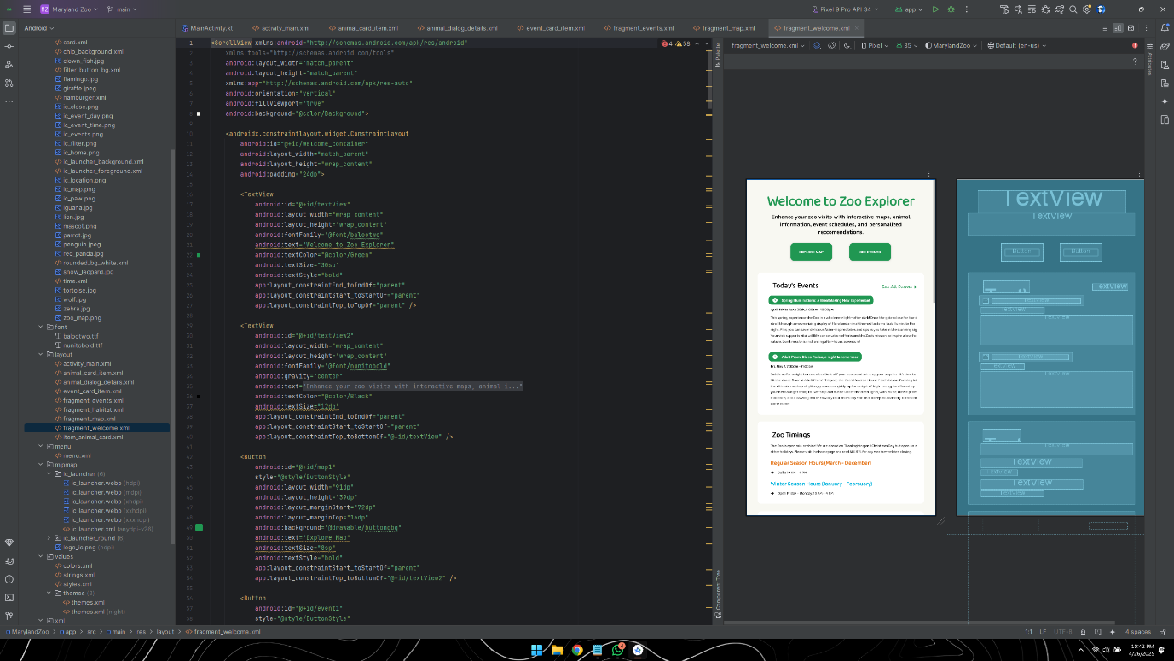

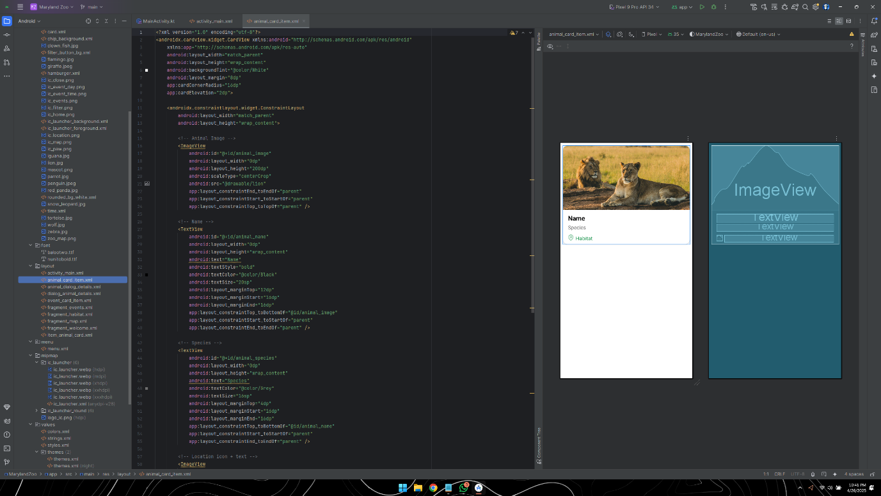

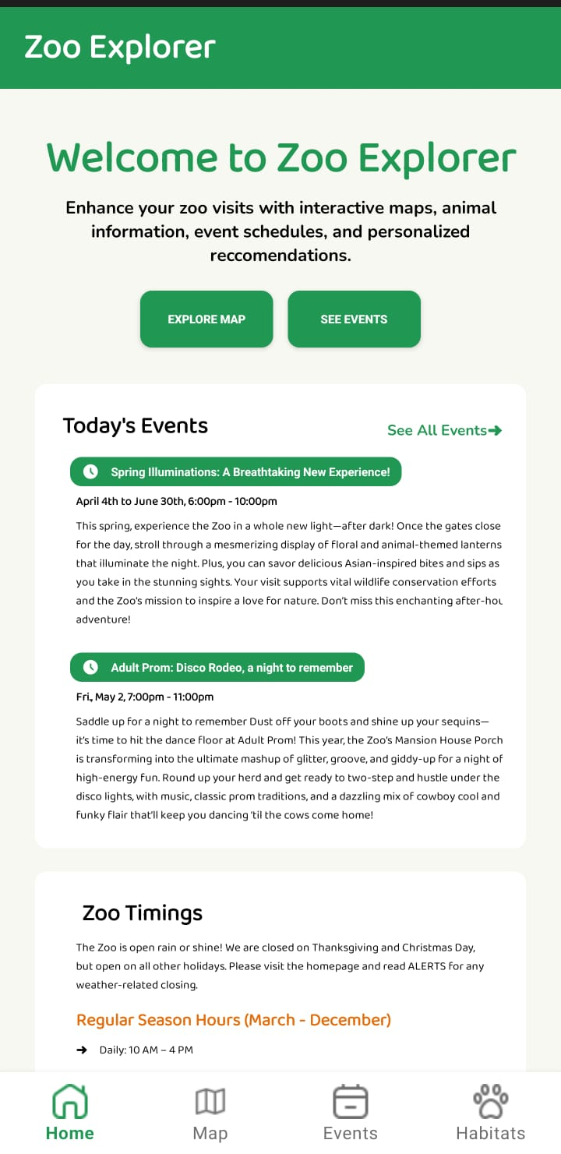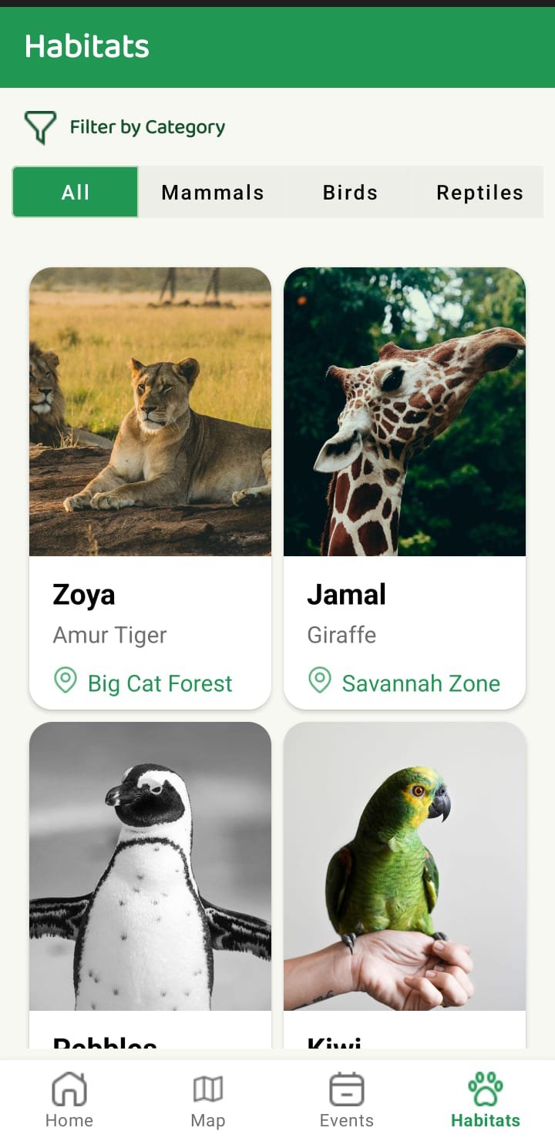

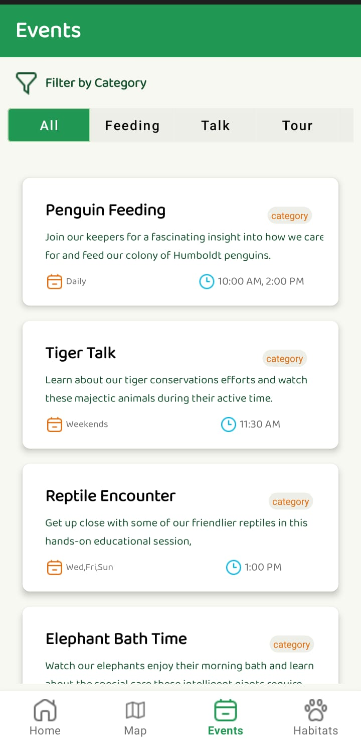

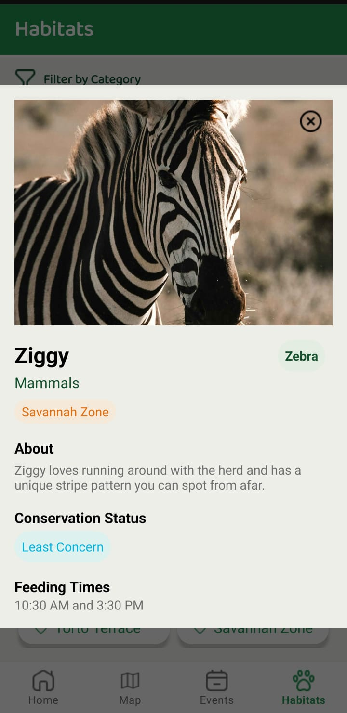

**Github Link:** <https://github.com/Illicitus25/Zoo-Explorer>